# Create the BuYnow APi

1. This API will aggregate the result from Order, Inventory and Email service with POST as method. The final response will have aggregated result.
2. Login to Azure Portal and navigate to Publisher Portal of API Management Service.
3. Click on Add new API manually and enter below details. Click on ‘Save’.

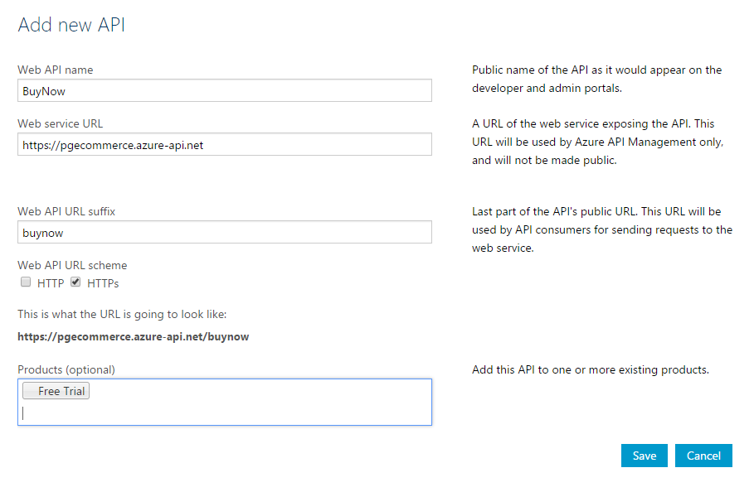

1. Add operation as:

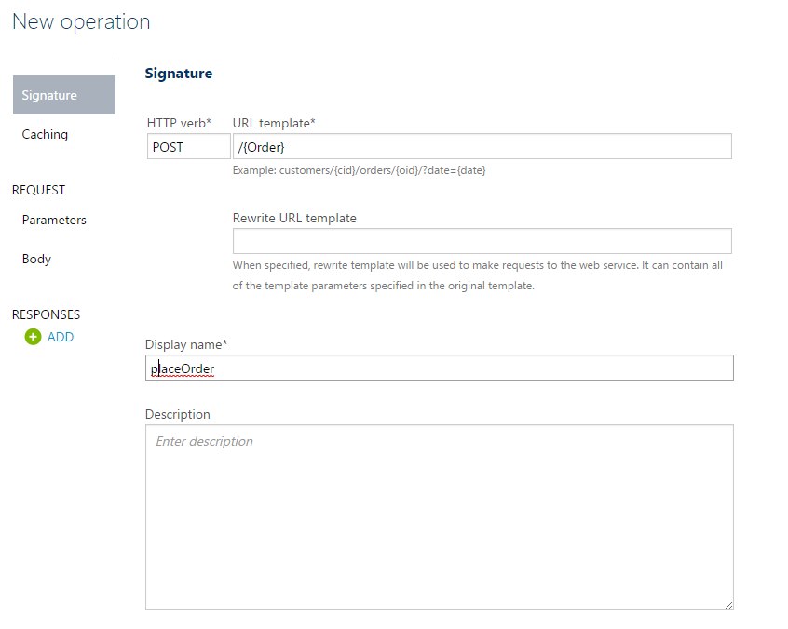

1. Go to Policy Editor and click a new policy.

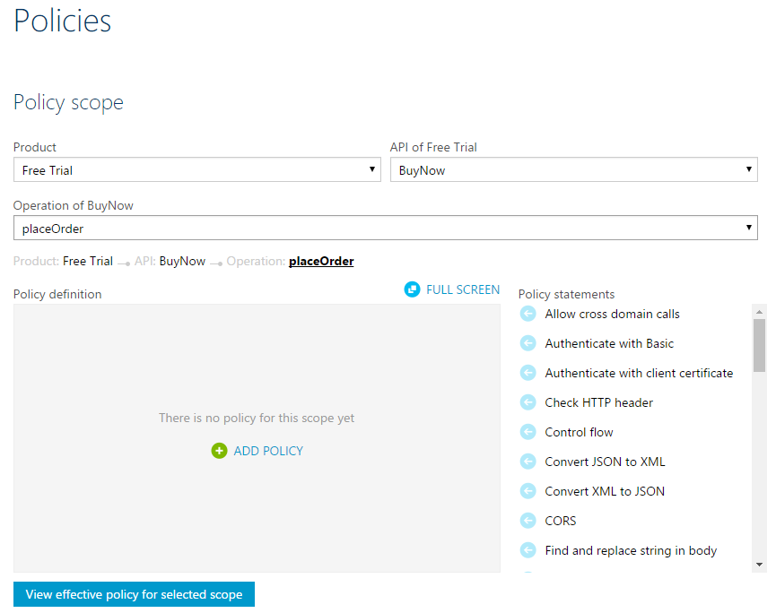

1. Update the policy as attached in text file:

